**New York Institute of Technology**

**School of Engineering and Computing Sciences**

NYIT Academy Summer Camp

VHDL Assignment 2:

Defining a Combinatorial Circuit using a Truth Table.

1. Enter the VHDL program below.

Library ieee;

Use ieee.std_logic_1164.all;

Entity Truth_Table is

Port(

D : in std_logic_vector (1 downto 0);

Y : out std_logic_vector (1 downto 0));

End Truth_Table;

Architecture Joe_Structure of Truth_Table is

Begin

with D select

Y <= "01" when "00",

"00" when "01",

"11" when "10",

"11" when "11";

End Joe_Structure;

1. Simulate the program and verify the truth table by using the Simulation Tool.

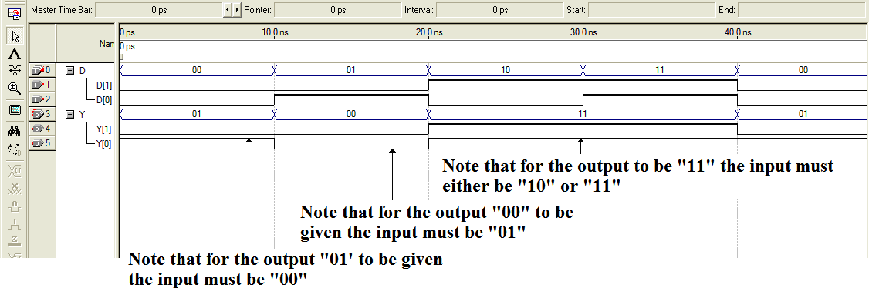

1. Create a VHDL truth table program for a 4 input Nand Gate.

1. Create a VHDL truth table program for a mux that has four inputs (I(0)-I(3)), one output, and two select lines. *Hint: Create a two component vector for the select lines, a four component vector for the data lines. Also, the first component of a vector I is I(0), the second component is I(1), etc.*